**TAREFA MODULO 9**

**Exercício 1: Relatório de Acessibilidade.**

- Site analisado: <http://lojaebac.ebaconline.art.br/>

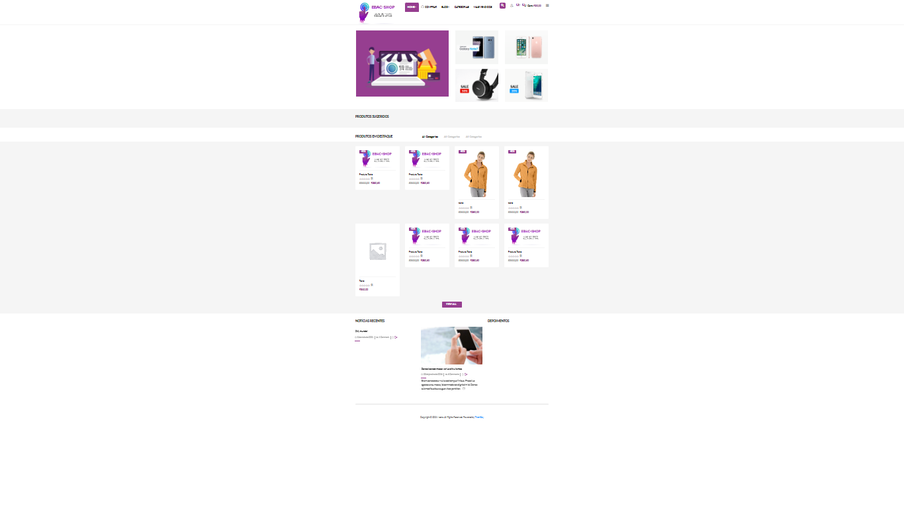

- Navegador: Google Chrome

- Ferramenta utilizada: lighthouse

Resultados:

**Performance 37; Accecibility 80; Best Practices 75; SEO 85; PWA**

**PERFORMANCE (37)**

**Metrics:**

- First Contentful Paint = 8.3 s ( é um carregamento inicial considerado lento)

- Speed Index = 19,8 s ( também representa uma velocidade de apresentação

do conteúdo de uma página baixa)

- Largest Contenful Paint = 9.1 s ( tempo de carregamento do maior texto ou

imagem longo)

- Time to Interactive = 15.9 s ( tempo para a pagina se tornar interativa longo)

- Total Blocking Time = 380 ms ( tempo entre o carregamento inicial, FCP e o

Inicio do Time to interactive moderado)

- Cumulative Layout Shift = 0,003 s ( tempo de resposta ao usuário bom)

**Sugestões para ajudar a aumentar a velocidade de carregamento da página:**

- Os recursos estão bloqueando a primeira apresentação da página. Considere

fornecer JS/CSS crítico em linha e adiar todos os estilos/JS não críticos.

- Reduza o uso de CSS (cascade style sheets)

- Reduza a resposta inicial do servidor

- Reduza os scripts Java não utilizados

- Faça as imagens em formato WebP e AviF que apresentam melhor

Compressão com mais rápido download e menor consumo de dados.

**Diagnosticos**

- Aproveite o recurso CSS de exibição de fonte para garantir que o texto fique

visível para o usuário enquanto as fontes da web estão sendo carregadas.

- As imagens maiores estão sendo recarregadas lentamente.

- A primeira imagem esta sendo carregada lentamente (16133 ms)

- Ativos estáticos com eficiente uso de cache ( 102 recursos encontrados)

- Evite o tamanho excessivo de dom (document object model)

- Minimize o tempo de trabalho do Java Script ( particionamento, compilação e

execução)

- Reduza o tamanho dos download adiando os downloads de recursos

desnecessários.

- Mantenha as solicitações baixas e os tamanhos de transferência pequenos

(113 requisições, 1,024 KiB)

- Elemento de imagem grande .(encontrado 1)

- Evite grandes mudanças no layout ( 4 elementos encontrados)

- Evite tarefas longas (17 encontradas)

**ACESSIBILIDADE: (80)**

**ARIA – Accessibility for Rich Internet Aplications**

- Elementos com ARIA que necessitam conter arquivos especificos derivados

(children) perderam alguns ou todos esses arquivos derivados necessários.

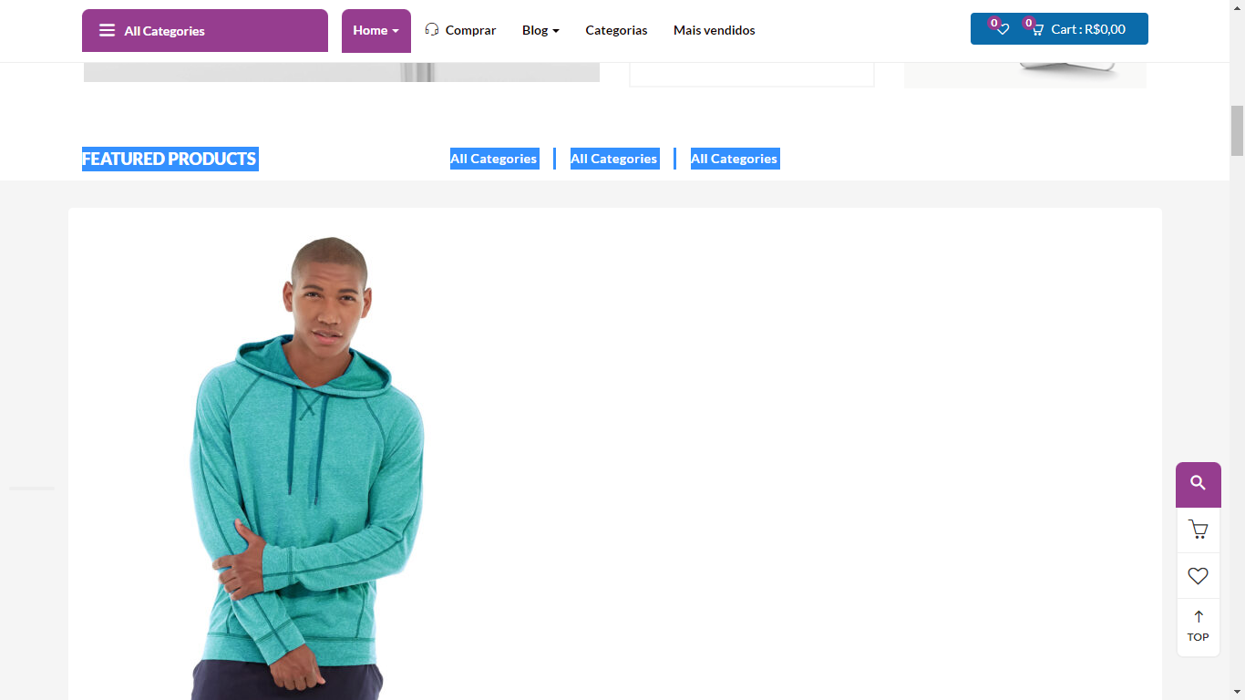 All Categories All Categories All Categories

<ul role="tablist" class="nav nav-tabs">

**Nomes e Rotulos**

- Botões sem nome acessível

| Failing Elements |
| --- |
| div.topbar-device-mobile > div.topbar-post > div.active-mobile > button.btn  <button data-toggle="offcanvas" class="btn btn-sm btn-danger btn-offcanvas btn-toggle-canvas offcanvas" type="button"> |

- links com nomes não discerníveis

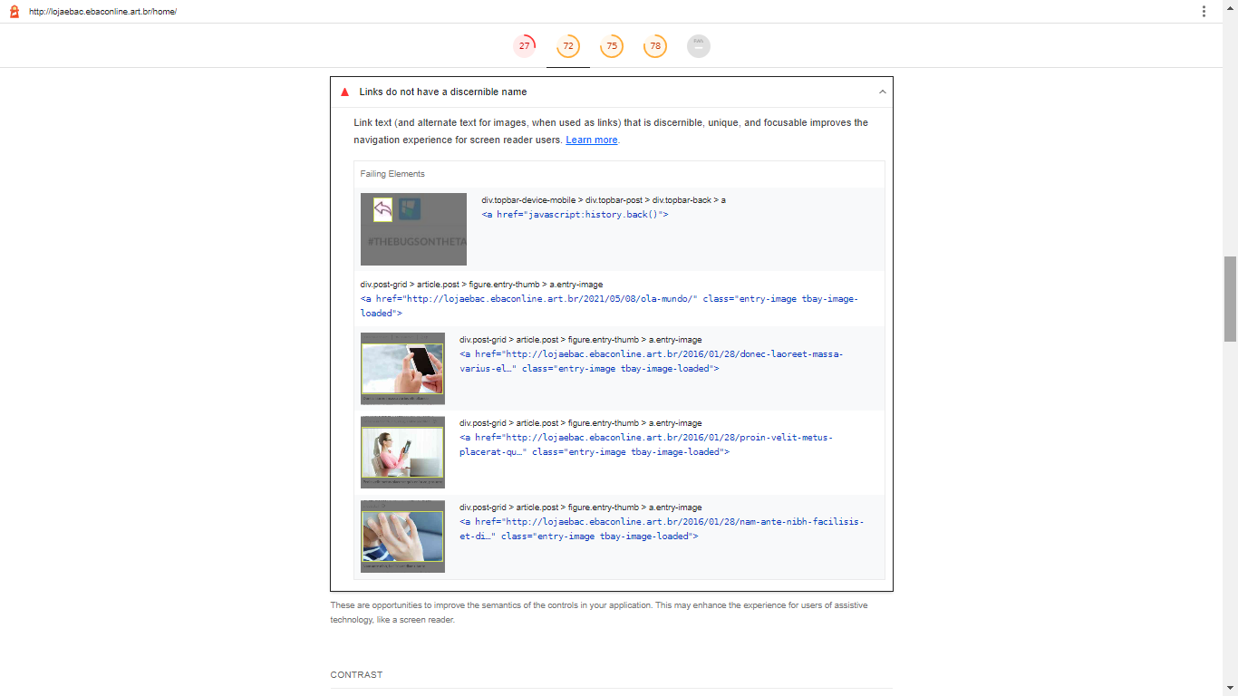

- Cores de Background e Foreground sem contraste suficiente

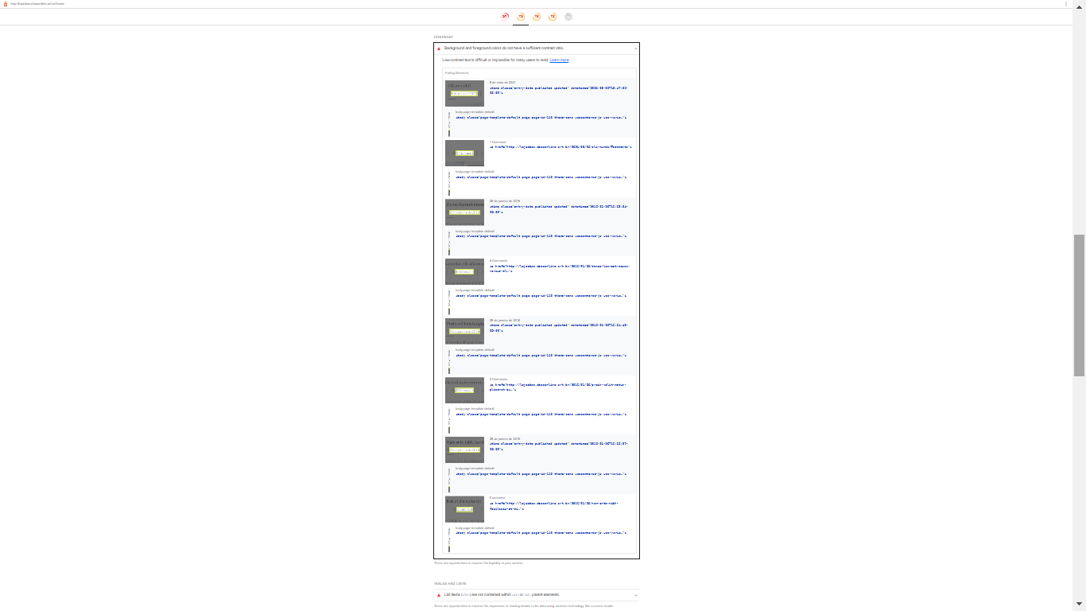

**Tabelas e Listas**

- Lista de itens ( < li >) não possuem elementos pais como <ul> ou<ol>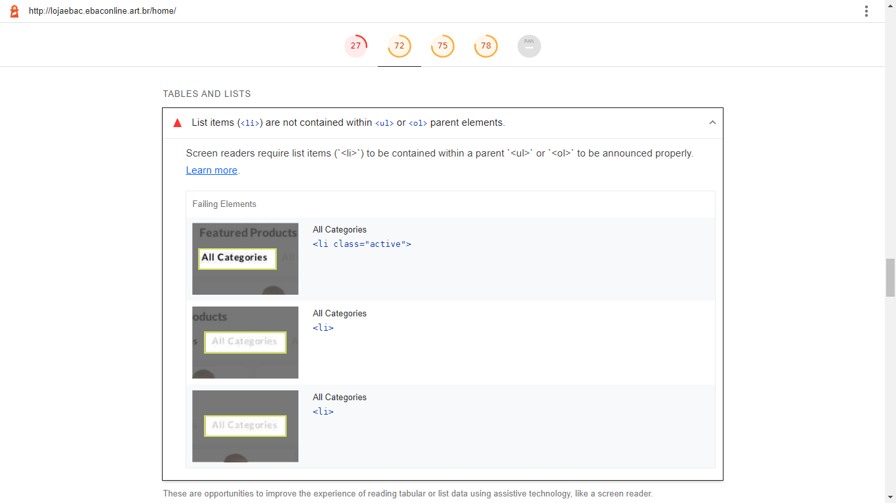

**BEST PRACTICES (75)**

- Confiança e Segurança

O site não utiliza HTTPS – 126 requisições inseguras encontradas

All sites should be protected with HTTPS, even ones that don't handle sensitive data. This includes avoiding mixed contente, where some resources are loaded over HTTP despite the initial request being served over HTTPS. HTTPS prevents intruders from tampering with or passively listening in on the communications between your app and your users, and is a prerequisite for HTTP/2 and many new web platform APIs.

| Insecure URL | Request Resolution |
| --- | --- |
| [/home/](http://lojaebac.ebaconline.art.br/home/)  (lojaebac.ebaconline.art.br) | Allowed |
| […gtranslate/gtranslate-style24.css?ver=6.1.1](http://lojaebac.ebaconline.art.br/wp-content/plugins/gtranslate/gtranslate-style24.css?ver=6.1.1)  (lojaebac.ebaconline.art.br) | Allowed |
| […block-library/style.min.css?ver=6.1.1](http://lojaebac.ebaconline.art.br/wp-includes/css/dist/block-library/style.min.css?ver=6.1.1)  (lojaebac.ebaconline.art.br) | Allowed |
| […mediaelement/mediaelementplayer-legacy.min.css?ver=4.2.17](http://lojaebac.ebaconline.art.br/wp-includes/js/mediaelement/mediaelementplayer-legacy.min.css?ver=4.2.17)  (lojaebac.ebaconline.art.br) | Allowed |
| […mediaelement/wp-mediaelement.min.css?ver=6.1.1](http://lojaebac.ebaconline.art.br/wp-includes/js/mediaelement/wp-mediaelement.min.css?ver=6.1.1)  (lojaebac.ebaconline.art.br) | Allowed |
| […build/vendors-style.css?ver=5.3.3](http://lojaebac.ebaconline.art.br/wp-content/plugins/woocommerce/packages/woocommerce-blocks/build/vendors-style.css?ver=5.3.3)  (lojaebac.ebaconline.art.br) | Allowed |
| […build/style.css?ver=5.3.3](http://lojaebac.ebaconline.art.br/wp-content/plugins/woocommerce/packages/woocommerce-blocks/build/style.css?ver=5.3.3)  (lojaebac.ebaconline.art.br) | Allowed |
| […css/jquery.selectBox.css?ver=1.2.0](http://lojaebac.ebaconline.art.br/wp-content/plugins/yith-woocommerce-wishlist/assets/css/jquery.selectBox.css?ver=1.2.0)  (lojaebac.ebaconline.art.br) | Allowed |
| […css/font-awesome.css?ver=4.7.0](http://lojaebac.ebaconline.art.br/wp-content/plugins/yith-woocommerce-wishlist/assets/css/font-awesome.css?ver=4.7.0)  (lojaebac.ebaconline.art.br) | Allowed |
| […css/prettyPhoto.css?ver=3.1.6](http://lojaebac.ebaconline.art.br/wp-content/plugins/woocommerce/assets/css/prettyPhoto.css?ver=3.1.6)  (lojaebac.ebaconline.art.br) | Allowed |
| […css/style.css?ver=3.0.25](http://lojaebac.ebaconline.art.br/wp-content/plugins/yith-woocommerce-wishlist/assets/css/style.css?ver=3.0.25)  (lojaebac.ebaconline.art.br) | Allowed |
| […css/classic-themes.min.css?ver=1](http://lojaebac.ebaconline.art.br/wp-includes/css/classic-themes.min.css?ver=1)  (lojaebac.ebaconline.art.br) | Allowed |
| […css/styles.css?ver=5.4.2](http://lojaebac.ebaconline.art.br/wp-content/plugins/contact-form-7/includes/css/styles.css?ver=5.4.2)  (lojaebac.ebaconline.art.br) | Allowed |
| […css/generate-rest-api-url-public.css?ver=1.0.0](http://lojaebac.ebaconline.art.br/wp-content/plugins/easily-generate-rest-api-url/public/css/generate-rest-api-url-public.css?ver=1.0.0)  (lojaebac.ebaconline.art.br) | Allowed |
| […css/rs6.css?ver=6.4.8](http://lojaebac.ebaconline.art.br/wp-content/plugins/revslider/public/assets/css/rs6.css?ver=6.4.8)  (lojaebac.ebaconline.art.br) | Allowed |
| […css/front.css?ver=2.2.5.1](http://lojaebac.ebaconline.art.br/wp-content/plugins/woocommerce-products-filter/css/front.css?ver=2.2.5.1)  (lojaebac.ebaconline.art.br) | Allowed |
| […chosen/chosen.min.css?ver=2.2.5.1](http://lojaebac.ebaconline.art.br/wp-content/plugins/woocommerce-products-filter/js/chosen/chosen.min.css?ver=2.2.5.1)  (lojaebac.ebaconline.art.br) | Allowed |
| […css/woocommerce-layout.css?ver=5.5.4](http://lojaebac.ebaconline.art.br/wp-content/plugins/woocommerce/assets/css/woocommerce-layout.css?ver=5.5.4)  (lojaebac.ebaconline.art.br) | Allowed |
| […css/woocommerce-smallscreen.css?ver=5.5.4](http://lojaebac.ebaconline.art.br/wp-content/plugins/woocommerce/assets/css/woocommerce-smallscreen.css?ver=5.5.4)  (lojaebac.ebaconline.art.br) | Allowed |
| […css/woocommerce.css?ver=5.5.4](http://lojaebac.ebaconline.art.br/wp-content/plugins/woocommerce/assets/css/woocommerce.css?ver=5.5.4)  (lojaebac.ebaconline.art.br) | Allowed |
| […css/yith-wcbr.css?ver=1.5.1](http://lojaebac.ebaconline.art.br/wp-content/plugins/yith-woocommerce-brands-add-on/assets/css/yith-wcbr.css?ver=1.5.1)  (lojaebac.ebaconline.art.br) | Allowed |
| […css/colorbox.css?ver=1.4.21](http://lojaebac.ebaconline.art.br/wp-content/plugins/yith-woocommerce-compare/assets/css/colorbox.css?ver=1.4.21)  (lojaebac.ebaconline.art.br) | Allowed |
| […css/yith-quick-view.css?ver=1.6.3](http://lojaebac.ebaconline.art.br/wp-content/plugins/yith-woocommerce-quick-view/assets/css/yith-quick-view.css?ver=1.6.3)  (lojaebac.ebaconline.art.br) | Allowed |
| [/css?family=…](http://fonts.googleapis.com/css?family=Raleway:400,300,500,600,700,800,900%7CMontserrat:400,700%7CLato:100,100i,300,300i,400,400i,700,700i,900,900i&subset=latin%2Clatin-ext&display=swap)  (fonts.googleapis.com) | Allowed |
| […css/js_composer.min.css?ver=6.6.0](http://lojaebac.ebaconline.art.br/wp-content/plugins/js_composer/assets/css/js_composer.min.css?ver=6.6.0)  (lojaebac.ebaconline.art.br) | Allowed |
| […css/frontend.min.css?ver=1.1.17](http://lojaebac.ebaconline.art.br/wp-content/plugins/woo-variation-swatches/assets/css/frontend.min.css?ver=1.1.17)  (lojaebac.ebaconline.art.br) | Allowed |
| […css/wvs-theme-override.min.css?ver=1.1.17](http://lojaebac.ebaconline.art.br/wp-content/plugins/woo-variation-swatches/assets/css/wvs-theme-override.min.css?ver=1.1.17)  (lojaebac.ebaconline.art.br) | Allowed |
| […css/frontend-tooltip.min.css?ver=1.1.17](http://lojaebac.ebaconline.art.br/wp-content/plugins/woo-variation-swatches/assets/css/frontend-tooltip.min.css?ver=1.1.17)  (lojaebac.ebaconline.art.br) | Allowed |
| […css/woocommerce.css?ver=2.8.8](http://lojaebac.ebaconline.art.br/wp-content/themes/cena/css/woocommerce.css?ver=2.8.8)  (lojaebac.ebaconline.art.br) | Allowed |
| […css/template.css?ver=2.8.8](http://lojaebac.ebaconline.art.br/wp-content/themes/cena/css/template.css?ver=2.8.8)  (lojaebac.ebaconline.art.br) | Allowed |
| […cena/style.css?ver=1.0](http://lojaebac.ebaconline.art.br/wp-content/themes/cena/style.css?ver=1.0)  (lojaebac.ebaconline.art.br) | Allowed |
| […css/simple-line-icons.css?ver=2.4.0](http://lojaebac.ebaconline.art.br/wp-content/themes/cena/css/simple-line-icons.css?ver=2.4.0)  (lojaebac.ebaconline.art.br) | Allowed |
| […css/themify-icons.css?ver=1.0.0](http://lojaebac.ebaconline.art.br/wp-content/themes/cena/css/themify-icons.css?ver=1.0.0)  (lojaebac.ebaconline.art.br) | Allowed |
| […css/material-design-iconic-font.min.css?ver=2.2.0](http://lojaebac.ebaconline.art.br/wp-content/themes/cena/css/material-design-iconic-font.min.css?ver=2.2.0)  (lojaebac.ebaconline.art.br) | Allowed |
| […css/animate.css?ver=3.5.0](http://lojaebac.ebaconline.art.br/wp-content/themes/cena/css/animate.css?ver=3.5.0)  (lojaebac.ebaconline.art.br) | Allowed |
| […css/jquery.treeview.css?ver=1.0.0](http://lojaebac.ebaconline.art.br/wp-content/themes/cena/css/jquery.treeview.css?ver=1.0.0)  (lojaebac.ebaconline.art.br) | Allowed |
| […cena-child/style.css?ver=1.0](http://lojaebac.ebaconline.art.br/wp-content/themes/cena-child/style.css?ver=1.0)  (lojaebac.ebaconline.art.br) | Allowed |
| […css/jetpack.css?ver=10.0](http://lojaebac.ebaconline.art.br/wp-content/plugins/jetpack/css/jetpack.css?ver=10.0)  (lojaebac.ebaconline.art.br) | Allowed |
| […jquery/jquery.min.js?ver=3.6.1](http://lojaebac.ebaconline.art.br/wp-includes/js/jquery/jquery.min.js?ver=3.6.1)  (lojaebac.ebaconline.art.br) | Allowed |
| […jquery/jquery-migrate.min.js?ver=3.3.2](http://lojaebac.ebaconline.art.br/wp-includes/js/jquery/jquery-migrate.min.js?ver=3.3.2)  (lojaebac.ebaconline.art.br) | Allowed |
| […js/generate-rest-api-url-public.js?ver=1.0.0](http://lojaebac.ebaconline.art.br/wp-content/plugins/easily-generate-rest-api-url/public/js/generate-rest-api-url-public.js?ver=1.0.0)  (lojaebac.ebaconline.art.br) | Allowed |
| […js/rbtools.min.js?ver=6.4.5](http://lojaebac.ebaconline.art.br/wp-content/plugins/revslider/public/assets/js/rbtools.min.js?ver=6.4.5)  (lojaebac.ebaconline.art.br) | Allowed |
| […js/rs6.min.js?ver=6.4.8](http://lojaebac.ebaconline.art.br/wp-content/plugins/revslider/public/assets/js/rs6.min.js?ver=6.4.8)  (lojaebac.ebaconline.art.br) | Allowed |
| […jquery-blockui/jquery.blockUI.min.js?ver=2.70](http://lojaebac.ebaconline.art.br/wp-content/plugins/woocommerce/assets/js/jquery-blockui/jquery.blockUI.min.js?ver=2.70)  (lojaebac.ebaconline.art.br) | Allowed |
| […frontend/add-to-cart.min.js?ver=5.5.4](http://lojaebac.ebaconline.art.br/wp-content/plugins/woocommerce/assets/js/frontend/add-to-cart.min.js?ver=5.5.4)  (lojaebac.ebaconline.art.br) | Allowed |
| […vendors/woocommerce-add-to-cart.js?ver=6.6.0](http://lojaebac.ebaconline.art.br/wp-content/plugins/js_composer/assets/js/vendors/woocommerce-add-to-cart.js?ver=6.6.0)  (lojaebac.ebaconline.art.br) | Allowed |
| […images/mobile-logo.png](http://lojaebac.ebaconline.art.br/wp-content/themes/cena/images/mobile-logo.png)  (lojaebac.ebaconline.art.br) | Allowed |
| […06/logopqn_1.png](http://lojaebac.ebaconline.art.br/wp-content/uploads/2021/06/logopqn_1.png)  (lojaebac.ebaconline.art.br) | Allowed |
| […08/bg_slider1.jpg](http://15.228.79.85/wp-content/uploads/2017/08/bg_slider1.jpg)  (15.228.79.85) | Allowed |
| […home1/slider1-11.png](http://15.228.79.85/wp-content/uploads/revslider/home1/slider1-11.png)  (15.228.79.85) | Allowed |
| […home1/slider1_21.png](http://15.228.79.85/wp-content/uploads/revslider/home1/slider1_21.png)  (15.228.79.85) | Allowed |
| […08/bg_slider3-2.jpg](http://15.228.79.85/wp-content/uploads/2017/08/bg_slider3-2.jpg)  (15.228.79.85) | Allowed |
| […08/bg_slider1_4-1.jpg](http://15.228.79.85/wp-content/uploads/2017/08/bg_slider1_4-1.jpg)  (15.228.79.85) | Allowed |
| […08/bg_slider1_2.jpg](http://15.228.79.85/wp-content/uploads/2017/08/bg_slider1_2.jpg)  (15.228.79.85) | Allowed |
| […home1/slider1_3-11.png](http://15.228.79.85/wp-content/uploads/revslider/home1/slider1_3-11.png)  (15.228.79.85) | Allowed |
| […css/font-awesome.css](http://lojaebac.ebaconline.art.br/wp-content/plugins/revslider/public/assets/fonts/font-awesome/css/font-awesome.css)  (lojaebac.ebaconline.art.br) | Allowed |
| […css/tooltipster.bundle.min.css?ver=2.2.5.1](http://lojaebac.ebaconline.art.br/wp-content/plugins/woocommerce-products-filter/js/tooltip/css/tooltipster.bundle.min.css?ver=2.2.5.1)  (lojaebac.ebaconline.art.br) | Allowed |
| […themes/tooltipst….min.css?ver=2.2.5.1](http://lojaebac.ebaconline.art.br/wp-content/plugins/woocommerce-products-filter/js/tooltip/css/plugins/tooltipster/sideTip/themes/tooltipster-sideTip-noir.min.css?ver=2.2.5.1)  (lojaebac.ebaconline.art.br) | Allowed |
| […css/sumoselect.css?ver=1.0.0](http://lojaebac.ebaconline.art.br/wp-content/themes/cena/css/sumoselect.css?ver=1.0.0)  (lojaebac.ebaconline.art.br) | Allowed |
| […photoswipe/photoswipe.min.css?ver=5.5.4](http://lojaebac.ebaconline.art.br/wp-content/plugins/woocommerce/assets/css/photoswipe/photoswipe.min.css?ver=5.5.4)  (lojaebac.ebaconline.art.br) | Allowed |
| […default-skin/default-skin.min.css?ver=5.5.4](http://lojaebac.ebaconline.art.br/wp-content/plugins/woocommerce/assets/css/photoswipe/default-skin/default-skin.min.css?ver=5.5.4)  (lojaebac.ebaconline.art.br) | Allowed |
| […ui/core.min.js?ver=1.13.2](http://lojaebac.ebaconline.art.br/wp-includes/js/jquery/ui/core.min.js?ver=1.13.2)  (lojaebac.ebaconline.art.br) | Allowed |
| […ui/menu.min.js?ver=1.13.2](http://lojaebac.ebaconline.art.br/wp-includes/js/jquery/ui/menu.min.js?ver=1.13.2)  (lojaebac.ebaconline.art.br) | Allowed |
| […vendor/regenerator-runtime.min.js?ver=0.13.9](http://lojaebac.ebaconline.art.br/wp-includes/js/dist/vendor/regenerator-runtime.min.js?ver=0.13.9)  (lojaebac.ebaconline.art.br) | Allowed |
| […vendor/wp-polyfill.min.js?ver=3.15.0](http://lojaebac.ebaconline.art.br/wp-includes/js/dist/vendor/wp-polyfill.min.js?ver=3.15.0)  (lojaebac.ebaconline.art.br) | Allowed |
| […dist/dom-ready.min.js?ver=392bdd4…](http://lojaebac.ebaconline.art.br/wp-includes/js/dist/dom-ready.min.js?ver=392bdd43726760d1f3ca)  (lojaebac.ebaconline.art.br) | Allowed |
| […dist/hooks.min.js?ver=4169d3c…](http://lojaebac.ebaconline.art.br/wp-includes/js/dist/hooks.min.js?ver=4169d3cf8e8d95a3d6d5)  (lojaebac.ebaconline.art.br) | Allowed |
| […dist/i18n.min.js?ver=9e794f3…](http://lojaebac.ebaconline.art.br/wp-includes/js/dist/i18n.min.js?ver=9e794f35a71bb98672ae)  (lojaebac.ebaconline.art.br) | Allowed |
| […dist/a11y.min.js?ver=ecce20f…](http://lojaebac.ebaconline.art.br/wp-includes/js/dist/a11y.min.js?ver=ecce20f002eda4c19664)  (lojaebac.ebaconline.art.br) | Allowed |
| […ui/autocomplete.min.js?ver=1.13.2](http://lojaebac.ebaconline.art.br/wp-includes/js/jquery/ui/autocomplete.min.js?ver=1.13.2)  (lojaebac.ebaconline.art.br) | Allowed |
| […js/autocomplete-search-init.js](http://lojaebac.ebaconline.art.br/wp-content/themes/cena/js/autocomplete-search-init.js)  (lojaebac.ebaconline.art.br) | Allowed |
| […js/jquery.selectBox.min.js?ver=1.2.0](http://lojaebac.ebaconline.art.br/wp-content/plugins/yith-woocommerce-wishlist/assets/js/jquery.selectBox.min.js?ver=1.2.0)  (lojaebac.ebaconline.art.br) | Allowed |
| […prettyPhoto/jquery.prettyPhoto.min.js?ver=3.1.6](http://lojaebac.ebaconline.art.br/wp-content/plugins/woocommerce/assets/js/prettyPhoto/jquery.prettyPhoto.min.js?ver=3.1.6)  (lojaebac.ebaconline.art.br) | Allowed |
| […js/jquery.yith-wcwl.min.js?ver=3.0.25](http://lojaebac.ebaconline.art.br/wp-content/plugins/yith-woocommerce-wishlist/assets/js/jquery.yith-wcwl.min.js?ver=3.0.25)  (lojaebac.ebaconline.art.br) | Allowed |
| […js/index.js?ver=5.4.2](http://lojaebac.ebaconline.art.br/wp-content/plugins/contact-form-7/includes/js/index.js?ver=5.4.2)  (lojaebac.ebaconline.art.br) | Allowed |
| […js-cookie/js.cookie.min.js?ver=2.1.4](http://lojaebac.ebaconline.art.br/wp-content/plugins/woocommerce/assets/js/js-cookie/js.cookie.min.js?ver=2.1.4)  (lojaebac.ebaconline.art.br) | Allowed |
| […frontend/woocommerce.min.js?ver=5.5.4](http://lojaebac.ebaconline.art.br/wp-content/plugins/woocommerce/assets/js/frontend/woocommerce.min.js?ver=5.5.4)  (lojaebac.ebaconline.art.br) | Allowed |
| […frontend/cart-fragments.min.js?ver=5.5.4](http://lojaebac.ebaconline.art.br/wp-content/plugins/woocommerce/assets/js/frontend/cart-fragments.min.js?ver=5.5.4)  (lojaebac.ebaconline.art.br) | Allowed |
| […js/woocompare.min.js?ver=2.5.3](http://lojaebac.ebaconline.art.br/wp-content/plugins/yith-woocommerce-compare/assets/js/woocompare.min.js?ver=2.5.3)  (lojaebac.ebaconline.art.br) | Allowed |
| […js/jquery.colorbox-min.js?ver=1.4.21](http://lojaebac.ebaconline.art.br/wp-content/plugins/yith-woocommerce-compare/assets/js/jquery.colorbox-min.js?ver=1.4.21)  (lojaebac.ebaconline.art.br) | Allowed |
| […js/frontend.min.js?ver=1.6.3](http://lojaebac.ebaconline.art.br/wp-content/plugins/yith-woocommerce-quick-view/assets/js/frontend.min.js?ver=1.6.3)  (lojaebac.ebaconline.art.br) | Allowed |
| […js/underscore.min.js?ver=1.13.4](http://lojaebac.ebaconline.art.br/wp-includes/js/underscore.min.js?ver=1.13.4)  (lojaebac.ebaconline.art.br) | Allowed |
| […js/wp-util.min.js?ver=6.1.1](http://lojaebac.ebaconline.art.br/wp-includes/js/wp-util.min.js?ver=6.1.1)  (lojaebac.ebaconline.art.br) | Allowed |
| […frontend/add-to-cart-variation.min.js?ver=5.5.4](http://lojaebac.ebaconline.art.br/wp-content/plugins/woocommerce/assets/js/frontend/add-to-cart-variation.min.js?ver=5.5.4)  (lojaebac.ebaconline.art.br) | Allowed |
| […js/frontend.min.js?ver=1.1.17](http://lojaebac.ebaconline.art.br/wp-content/plugins/woo-variation-swatches/assets/js/frontend.min.js?ver=1.1.17)  (lojaebac.ebaconline.art.br) | Allowed |
| […frontend/single-product.min.js?ver=5.5.4](http://lojaebac.ebaconline.art.br/wp-content/plugins/woocommerce/assets/js/frontend/single-product.min.js?ver=5.5.4)  (lojaebac.ebaconline.art.br) | Allowed |
| […flexslider/jquery.flexslider.min.js?ver=6.6.0](http://lojaebac.ebaconline.art.br/wp-content/plugins/js_composer/assets/lib/flexslider/jquery.flexslider.min.js?ver=6.6.0)  (lojaebac.ebaconline.art.br) | Allowed |
| […js/skip-link-cena-fix.min.js?ver=20141010](http://lojaebac.ebaconline.art.br/wp-content/themes/cena/js/skip-link-cena-fix.min.js?ver=20141010)  (lojaebac.ebaconline.art.br) | Allowed |
| […js/jquery.treeview.min.js?ver=20150330](http://lojaebac.ebaconline.art.br/wp-content/themes/cena/js/jquery.treeview.min.js?ver=20150330)  (lojaebac.ebaconline.art.br) | Allowed |
| […js/bootstrap.min.js?ver=20150330](http://lojaebac.ebaconline.art.br/wp-content/themes/cena/js/bootstrap.min.js?ver=20150330)  (lojaebac.ebaconline.art.br) | Allowed |
| […dist/js_composer_front.min.js?ver=6.6.0](http://lojaebac.ebaconline.art.br/wp-content/plugins/js_composer/assets/js/dist/js_composer_front.min.js?ver=6.6.0)  (lojaebac.ebaconline.art.br) | Allowed |
| […js/wishlist.min.js?ver=1.0.0](http://lojaebac.ebaconline.art.br/wp-content/themes/cena/js/wishlist.min.js?ver=1.0.0)  (lojaebac.ebaconline.art.br) | Allowed |
| […js/woocommerce.min.js?ver=20150330](http://lojaebac.ebaconline.art.br/wp-content/themes/cena/js/woocommerce.min.js?ver=20150330)  (lojaebac.ebaconline.art.br) | Allowed |
| […js/functions.min.js?ver=20150330](http://lojaebac.ebaconline.art.br/wp-content/themes/cena/js/functions.min.js?ver=20150330)  (lojaebac.ebaconline.art.br) | Allowed |
| […js/tooltipster.bundle.min.js?ver=2.2.5.1](http://lojaebac.ebaconline.art.br/wp-content/plugins/woocommerce-products-filter/js/tooltip/js/tooltipster.bundle.min.js?ver=2.2.5.1)  (lojaebac.ebaconline.art.br) | Allowed |
| […js/front.js?ver=2.2.5.1](http://lojaebac.ebaconline.art.br/wp-content/plugins/woocommerce-products-filter/js/front.js?ver=2.2.5.1)  (lojaebac.ebaconline.art.br) | Allowed |
| […html_types/radio.js?ver=2.2.5.1](http://lojaebac.ebaconline.art.br/wp-content/plugins/woocommerce-products-filter/js/html_types/radio.js?ver=2.2.5.1)  (lojaebac.ebaconline.art.br) | Allowed |
| […html_types/checkbox.js?ver=2.2.5.1](http://lojaebac.ebaconline.art.br/wp-content/plugins/woocommerce-products-filter/js/html_types/checkbox.js?ver=2.2.5.1)  (lojaebac.ebaconline.art.br) | Allowed |
| […html_types/select.js?ver=2.2.5.1](http://lojaebac.ebaconline.art.br/wp-content/plugins/woocommerce-products-filter/js/html_types/select.js?ver=2.2.5.1)  (lojaebac.ebaconline.art.br) | Allowed |
| […html_types/mselect.js?ver=2.2.5.1](http://lojaebac.ebaconline.art.br/wp-content/plugins/woocommerce-products-filter/js/html_types/mselect.js?ver=2.2.5.1)  (lojaebac.ebaconline.art.br) | Allowed |
| […chosen/chosen.jquery.min.js?ver=2.2.5.1](http://lojaebac.ebaconline.art.br/wp-content/plugins/woocommerce-products-filter/js/chosen/chosen.jquery.min.js?ver=2.2.5.1)  (lojaebac.ebaconline.art.br) | Allowed |
| […js/jquery.sumoselect.min.js?ver=3.0.2](http://lojaebac.ebaconline.art.br/wp-content/themes/cena/js/jquery.sumoselect.min.js?ver=3.0.2)  (lojaebac.ebaconline.art.br) | Allowed |
| […js/owl.carousel.min.js?ver=2.0.0](http://lojaebac.ebaconline.art.br/wp-content/themes/cena/js/owl.carousel.min.js?ver=2.0.0)  (lojaebac.ebaconline.art.br) | Allowed |
| […zoom/jquery.zoom.min.js?ver=1.7.21](http://lojaebac.ebaconline.art.br/wp-content/plugins/woocommerce/assets/js/zoom/jquery.zoom.min.js?ver=1.7.21)  (lojaebac.ebaconline.art.br) | Allowed |
| […photoswipe/photoswipe.min.js?ver=4.1.1](http://lojaebac.ebaconline.art.br/wp-content/plugins/woocommerce/assets/js/photoswipe/photoswipe.min.js?ver=4.1.1)  (lojaebac.ebaconline.art.br) | Allowed |
| […photoswipe/photoswipe-ui-default.min.js?ver=4.1.1](http://lojaebac.ebaconline.art.br/wp-content/plugins/woocommerce/assets/js/photoswipe/photoswipe-ui-default.min.js?ver=4.1.1)  (lojaebac.ebaconline.art.br) | Allowed |
| […js/wp-emoji-release.min.js?ver=6.1.1](http://lojaebac.ebaconline.art.br/wp-includes/js/wp-emoji-release.min.js?ver=6.1.1)  (lojaebac.ebaconline.art.br) | Allowed |
| […v23/S6u9w4BMU….woff2](http://fonts.gstatic.com/s/lato/v23/S6u9w4BMUTPHh6UVSwiPGQ3q5d0.woff2)  (fonts.gstatic.com) | Allowed |
| […v23/S6uyw4BMU….woff2](http://fonts.gstatic.com/s/lato/v23/S6uyw4BMUTPHjx4wXiWtFCc.woff2)  (fonts.gstatic.com) | Allowed |
| […fonts/Simple-Line-Icons.woff2?v=2.4.0](http://lojaebac.ebaconline.art.br/wp-content/themes/cena/fonts/Simple-Line-Icons.woff2?v=2.4.0)  (lojaebac.ebaconline.art.br) | Allowed |
| […v23/S6u9w4BMU….woff2](http://fonts.gstatic.com/s/lato/v23/S6u9w4BMUTPHh50XSwiPGQ3q5d0.woff2)  (fonts.gstatic.com) | Allowed |
| […fonts/fontawesome-webfont.woff2?v=4.7.0](http://lojaebac.ebaconline.art.br/wp-content/plugins/revslider/public/assets/fonts/font-awesome/fonts/fontawesome-webfont.woff2?v=4.7.0)  (lojaebac.ebaconline.art.br) | Allowed |
| […fonts/star.woff](http://lojaebac.ebaconline.art.br/wp-content/plugins/woocommerce/assets/fonts/star.woff)  (lojaebac.ebaconline.art.br) | Allowed |
| […05/mh09-blue_main-427x546.jpg](http://lojaebac.ebaconline.art.br/wp-content/uploads/2021/05/mh09-blue_main-427x546.jpg)  (lojaebac.ebaconline.art.br) | Allowed |
| […05/ms01-blue_main-427x546.jpg](http://lojaebac.ebaconline.art.br/wp-content/uploads/2021/05/ms01-blue_main-427x546.jpg)  (lojaebac.ebaconline.art.br) | Allowed |
| […05/wh09-purple_main-427x546.jpg](http://lojaebac.ebaconline.art.br/wp-content/uploads/2021/05/wh09-purple_main-427x546.jpg)  (lojaebac.ebaconline.art.br) | Allowed |
| […05/mt11-blue_main-427x546.jpg](http://lojaebac.ebaconline.art.br/wp-content/uploads/2021/05/mt11-blue_main-427x546.jpg)  (lojaebac.ebaconline.art.br) | Allowed |
| […05/mh12-green_main-427x546.jpg](http://lojaebac.ebaconline.art.br/wp-content/uploads/2021/05/mh12-green_main-427x546.jpg)  (lojaebac.ebaconline.art.br) | Allowed |
| […05/mp11-brown_main-427x546.jpg](http://lojaebac.ebaconline.art.br/wp-content/uploads/2021/05/mp11-brown_main-427x546.jpg)  (lojaebac.ebaconline.art.br) | Allowed |
| […05/msh11-blue_main-427x546.jpg](http://lojaebac.ebaconline.art.br/wp-content/uploads/2021/05/msh11-blue_main-427x546.jpg)  (lojaebac.ebaconline.art.br) | Allowed |
| […05/wj04-white_main-427x546.jpg](http://lojaebac.ebaconline.art.br/wp-content/uploads/2021/05/wj04-white_main-427x546.jpg)  (lojaebac.ebaconline.art.br) | Allowed |
| [/g.gif?v=…](http://pixel.wp.com/g.gif?v=ext&j=1%3A10.0&blog=192863296&post=110&tz=-3&srv=lojaebac.ebaconline.art.br&host=lojaebac.ebaconline.art.br&ref=&fcp=6732&rand=0.6910176605769589)  (pixel.wp.com) | Allowed |
| [/?wc-ajax=get_refreshed_fragments](http://lojaebac.ebaconline.art.br/?wc-ajax=get_refreshed_fragments)  (lojaebac.ebaconline.art.br) | Allowed |
| […assets/loader.gif](http://lojaebac.ebaconline.art.br/wp-content/plugins/revslider/public/assets/assets/loader.gif)  (lojaebac.ebaconline.art.br) | Allowed |
| […revicons/revicons.woff?5510888](http://lojaebac.ebaconline.art.br/wp-content/plugins/revslider/public/assets/fonts/revicons/revicons.woff?5510888)  (lojaebac.ebaconline.art.br) | Allowed |
| [/wp-admin/admin-ajax.php](http://lojaebac.ebaconline.art.br/wp-admin/admin-ajax.php)  (lojaebac.ebaconline.art.br) | Allowed |

A strong Content Security Policy (CSP) significantly reduces the risk of cross-site scripting (XSS) attacks.

| Description | Directive | Severity |
| --- | --- | --- |
| No CSP found in enforcement mode |  | High |
|  |  |  |

- Imagens apresentadas combaixa resolução e relação de aspecto incorreta

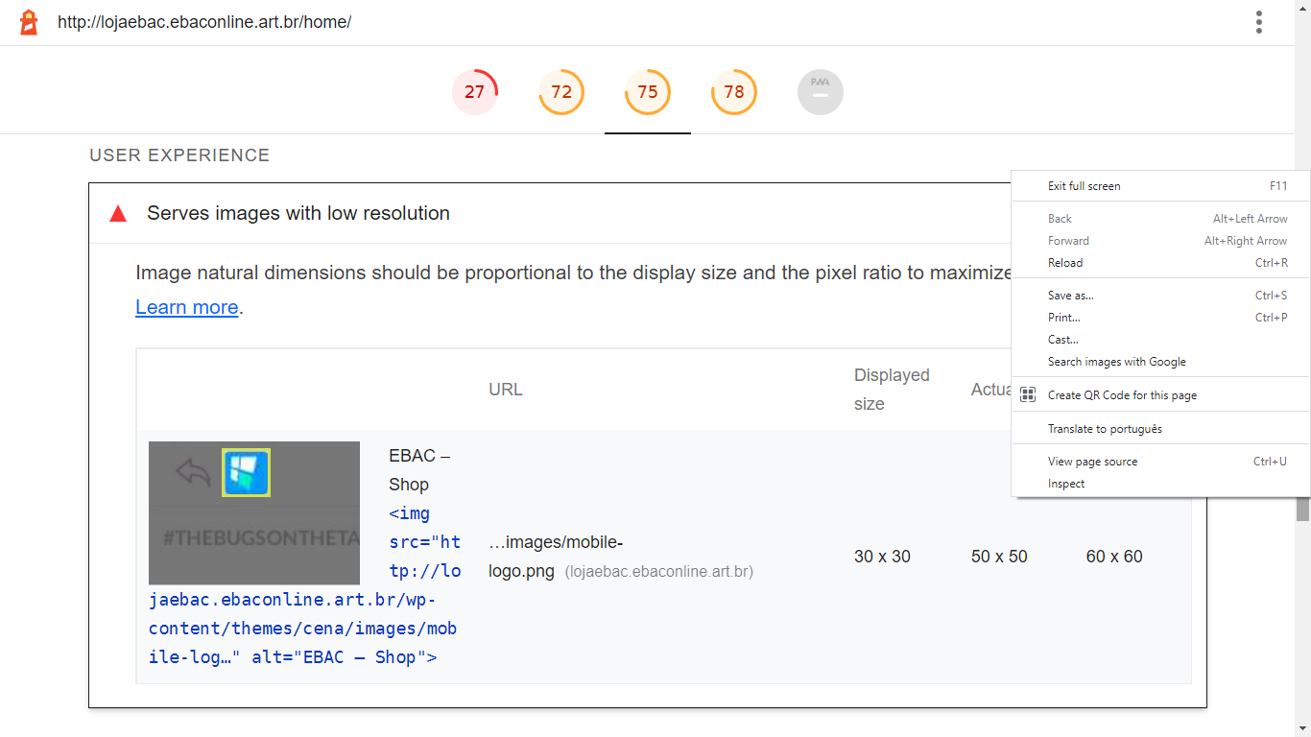

**Geral**

- Bibliotecas JavaScript detectadas

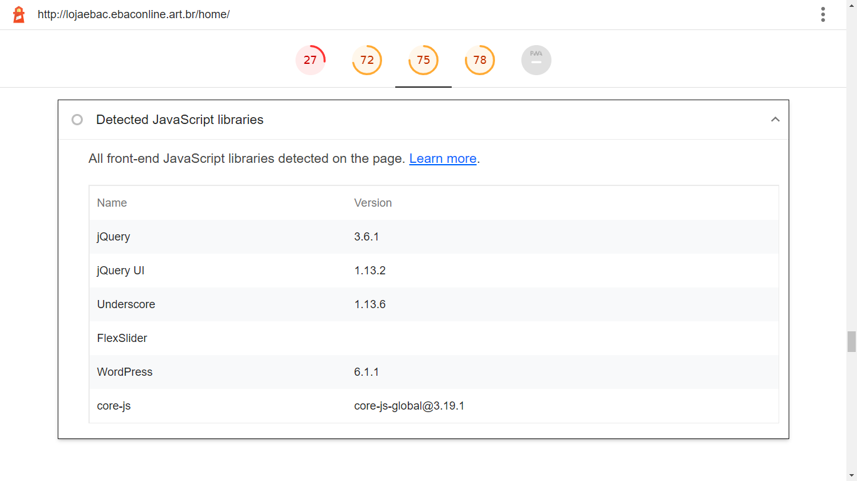

**SEO – Search Engine Optimization (85)**

**Melhores praticas de Conteudo**

- O documento não possui uma descrição do objetivo (meta) da pagina

- Crawling e Indexing

A página é bloqueada para indexing.

- Alvos de toques com tamanhos não apropriados- 98% apropriados

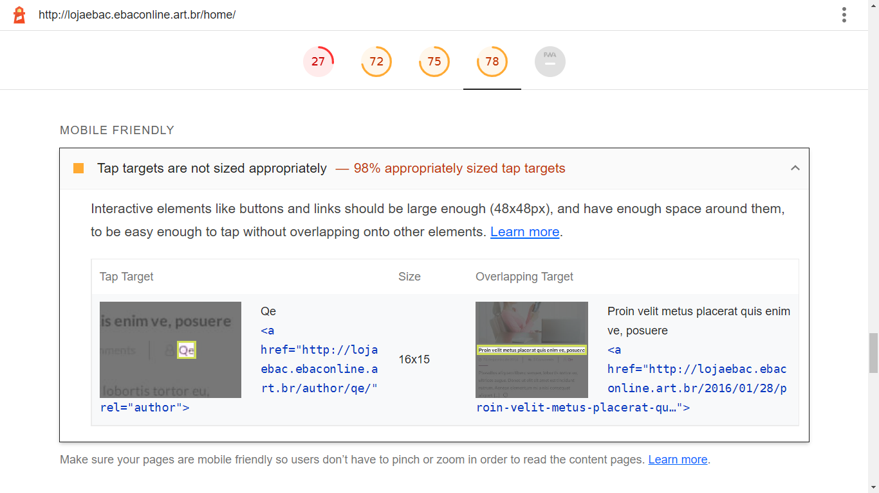

**PWA – Progressive Web App (75)**

**Installable**

- O aplicativo Web ou trabalho não atende aos requisitos de instalação

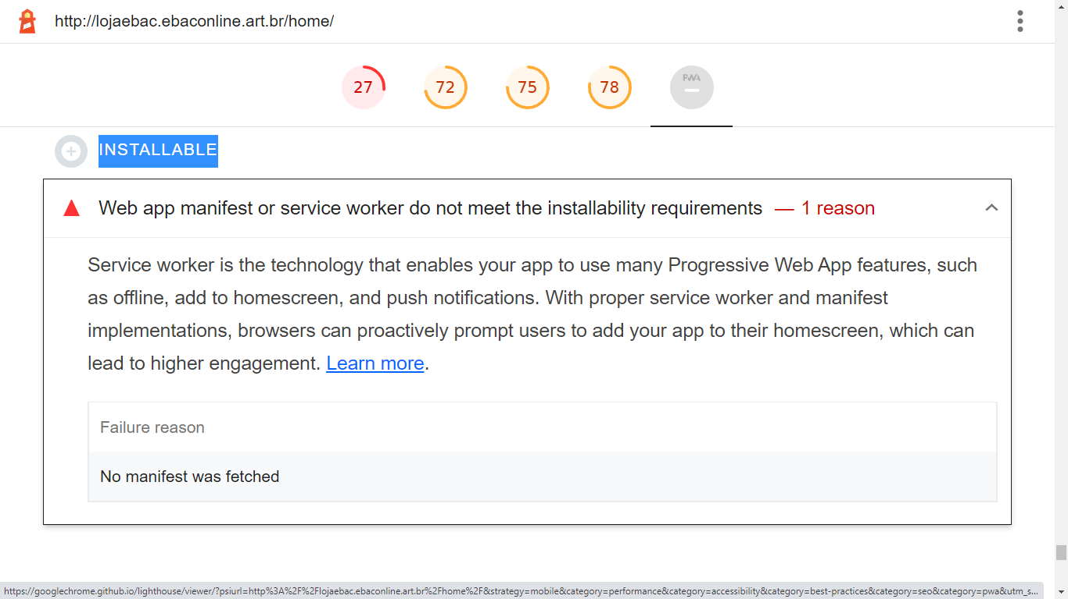

**PWA Optimized**

- Não registra um serviço de trabalho que controla a pagina e start_url

Não permitindo a utilização de características progressivas de aplicativos

- Não esta configurado como uma tela inicial personalizada.

- A barra de endereços não tem cor definida

Falhas: Nenhum manifesto foi buscado, nenhuma tag `<meta name="theme-

color">` encontrada.

- O conteúdo esta dimensionado corretamente para a janela de visualização

- Tem uma tag <meta name="viewport"> com largura ou escala inicial

- Não fornece um ícone apple-touch´-icone válido

- O manifesto não tem um ícone mascarável Nenhum manifesto foi obtido

Um ícone mascarável garante que a imagem preencha toda a tela sem ficar

em formato de caixa de correio ao instalar o aplicativo em um dispositivo.